**LAB 04**

# Tasks Related to Arithmetic Operators

1. Write a Python program to take two numbers as input and perform all arithmetic operations on them.

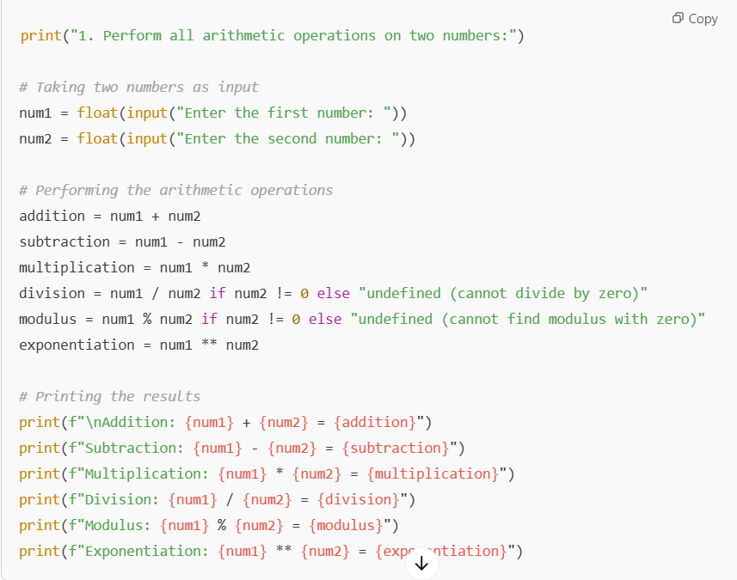

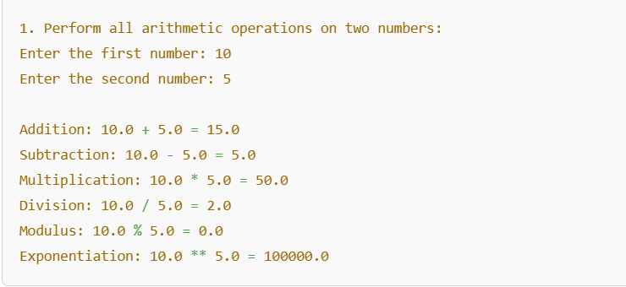

1. Create a function that takes two numbers and returns their sum, difference, product, and quotient.

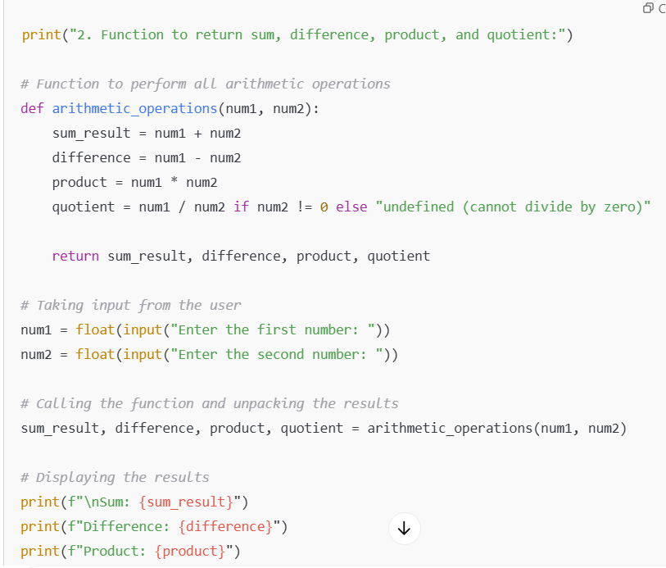

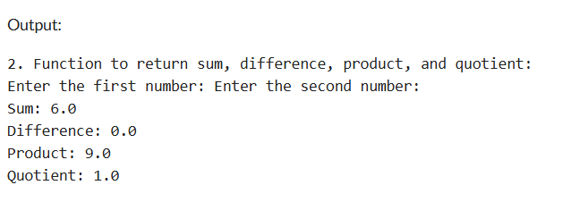

1. Write a Python script to find the remainder when one number is divided by another.

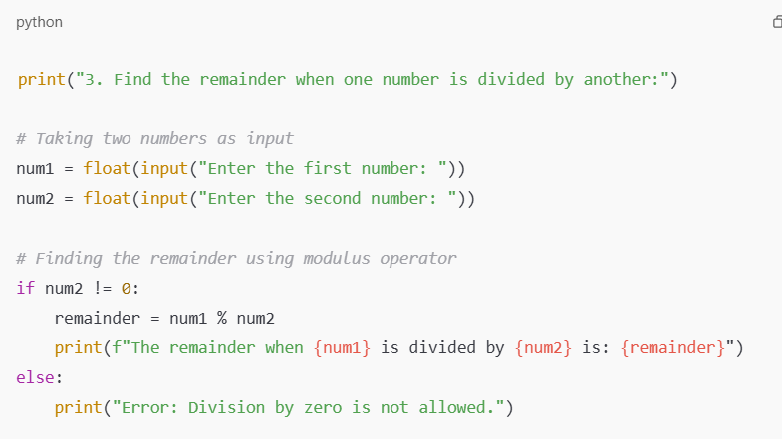

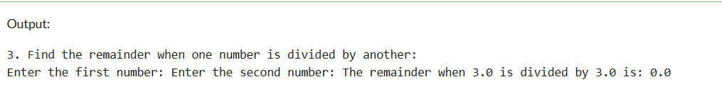

1. Write a program to calculate the area of a circle using the formula: Area = π * r^2.

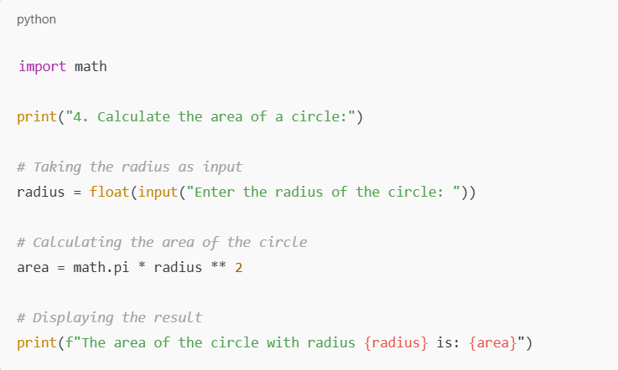

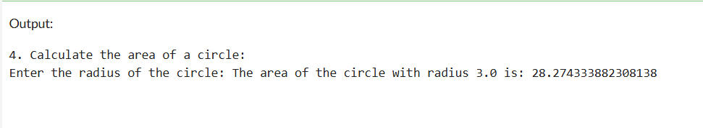

1. Implement a program that takes a number as input and returns its square and cube using exponentiation.

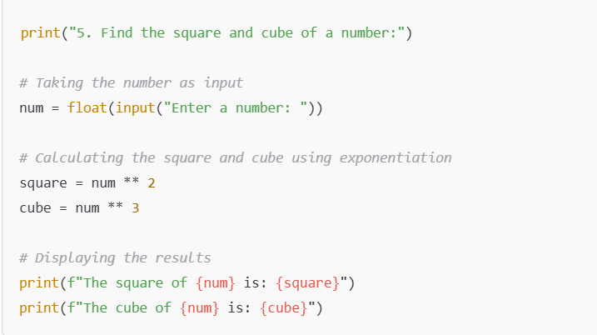

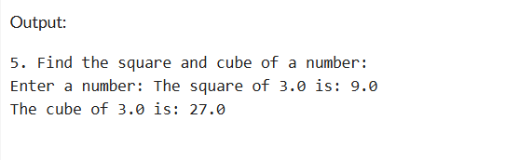

1. Create a simple calculator in Python that allows the user to choose an operation (addition, subtraction, etc.) and inputs two numbers.

